4 components that make up JDBC Architecture :

- JDBC Client – the app that we are developing
- JDBC API
- JDBC Driver – interface between our code and the underlying database.
- JDBC DriverManager – helper class which finds the driver and establishes a connection to the database.

JDBC API is part of java.sql.*; package. The API comprises of many interfaces and classes(like, Connection, Statement, ResultSet, etc) that we use to interact with Database.

JDBC Drivers :

These drivers implement the JDBC specification and is the interface between client code and the DB.

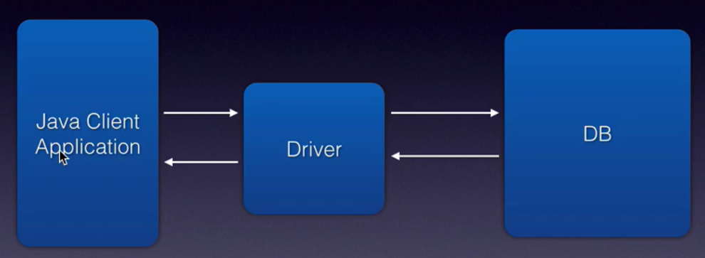

JDBC Client code and the type of operations we do :

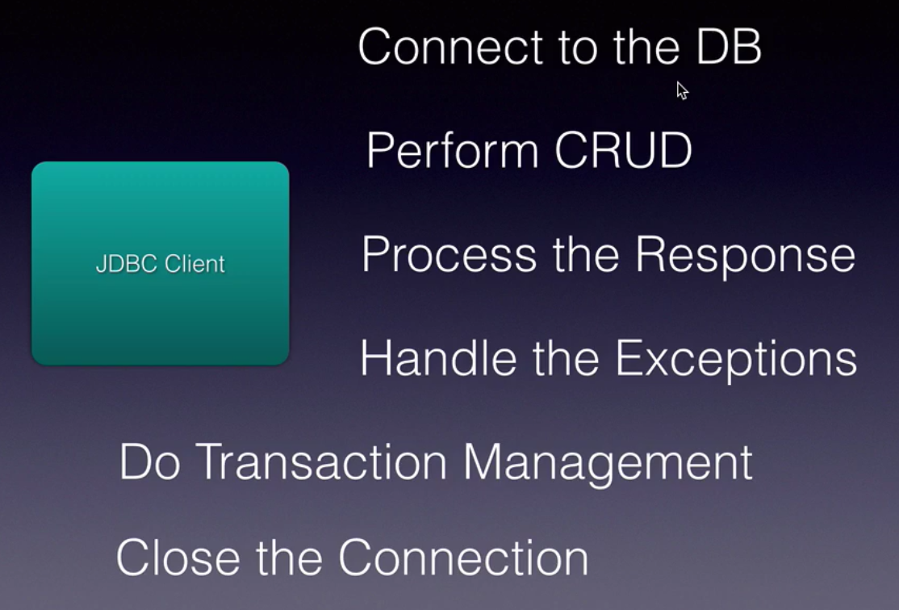

DriverManager :

Our JDBC Client code uses the DriverManager helper class ONLY ONCE to find the appropriate Driver class to connect to the database and it establishes a connection through the driver and returns the connection back to the Client code.

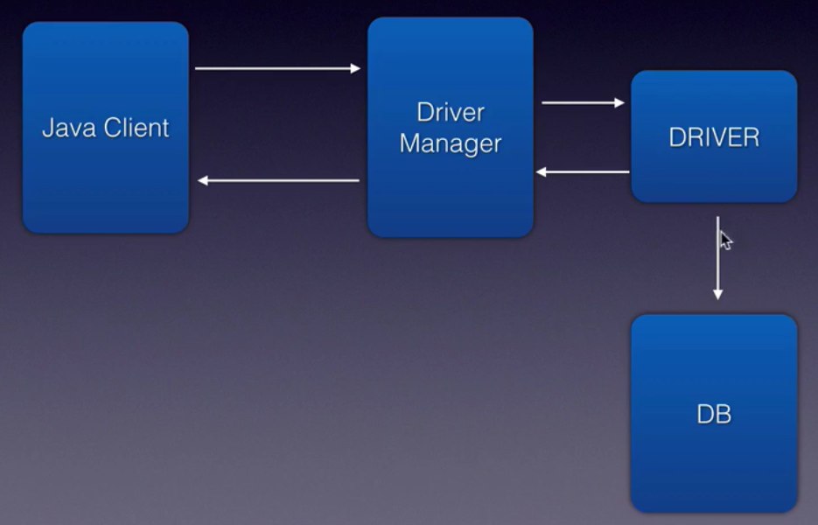

Create the Account table :

use mylocaldb;
create table account(accno int,lastname varchar(25),firstname varchar(25),bal int)
select * from account;

Steps to perform CRUD operations :

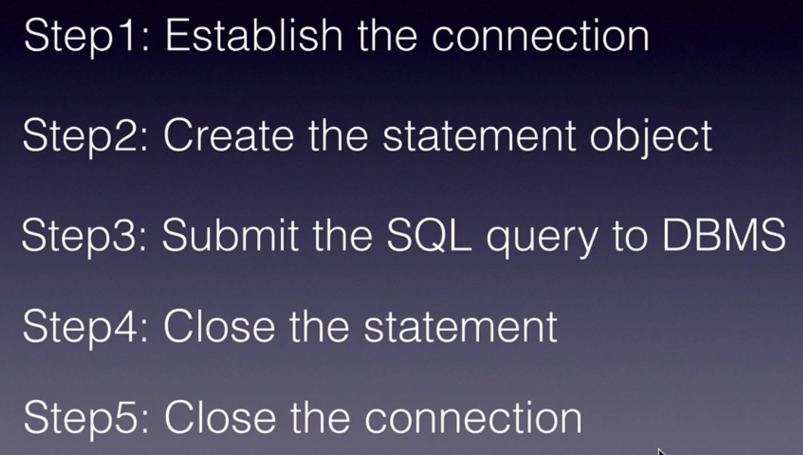

Create a simple Java project with name : JDBCBasics.
In this project, create a new folder named 'lib'.
Download the driver jar file : mysql-connector-java-5.1.41-bin.jar and add it to the project lib folder.

Add the driver JAR file to the build path -> Libraries. Then, the project will show the driver JAR file in Referenced Libraries.

Class.forName( ) is not needed since JDBC 4.0.

Any JDBC 4.0 drivers that are found in your class path are automatically loaded. (However, you must manually load any drivers prior to JDBC 4.0 with the method Class.forName.) In previous versions of JDBC, to obtain a connection, you first had to initialize your JDBC driver by calling the method Class.forName. This methods required an object of type java.sql.Driver. Each JDBC driver contains one or more classes that implements the interface java.sql.Driver.
Step 1: Connect to the Database

Connection myConn = DriverManager.getConnection(
"jdbc:mysql://localhost/mylocaldb", "root", "chotu123");

What is connection string ??

Connection String varies from database to database and is used to connect to the database.

For mySQL database : "jdbc:mysql://localhost/test"
For oracle database:

Using host:port:sid syntax

"jdbc:oracle:thin:@prodHost:1521:ORCL"

Using TNS syntax :
String connString = "jdbc:oracle:thin:@(description=(address_list=
(address=(protocol=tcp)(port=1521)(host=prodHost)))
(connect_data=(INSTANCE_NAME=ORCL)))";

Step 2: Create Statement object

Statement is a key interface to create the DML and DQL statements.

How do you create Statement object ??

Statement stmt = myConn.createStatement();

Then, we can use this statement instance to execute SQL queries. 2 methods of importance.

For Insert, Update, Delete operations, --> use stmt.executeUpdate(" ") method. It returns an integer which indicate the number of records effected by the DML query.

For select queries -> use stmt.executeQuery(" ") method. It returns a ResultSet object which contans the list of rows/records returned by the select query.
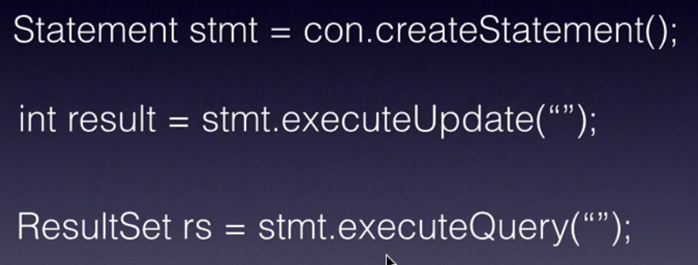

Insert a record into Account table in database :

We are going to Statement object and the method executeUpdate.

try {
Connection myConn = DriverManager.getConnection(
"jdbc:mysql://localhost/mylocaldb", "root", "chotu123");

Statement statement = myConn.createStatement();
int result = statement.executeUpdate(
"insert into account values(1, 'Dayala', 'Raghu', 10000)");

System.out.println(result + " rows got inserted..");

myConn.close();
} catch (SQLException e) {
e.printStackTrace();
}

Update a record :

int result = statement.executeUpdate(
"update account set bal = 20000 where accno = 1");
System.out.println(result + " rows got updated..");

Delete a record :

int result = statement.executeUpdate("delete from account where accno = 1");

System.out.println(result + " rows got deleted..");

Reading data from DB using JDBC : Select Query :

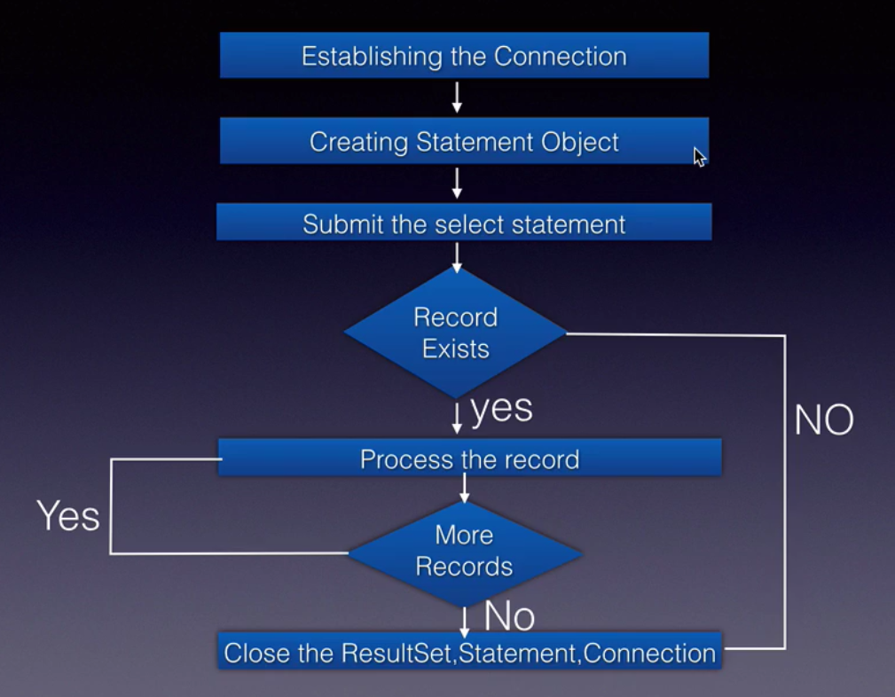

When we execute the query, the returned rows will be a list of records stored in ResultSet object.

ResultSet rs = statement.executeQuery("select * from account");
while(rs.next()){
// column index starts from 1
System.out.print(rs.getString(2)+ " "); // lastname
System.out.print(rs.getString(3)+ " "); // firstname
System.out.println(rs.getString(4)); // balance
}

Clean up JDBC Resources :
Before Java 7, we need to explicitly close the resources in the finally block.
From Java 7 onwards, we can use try-with-resources block as the JDBC interfaces implement AutoCloseable.

try(Connection myConn =
DriverManager.getConnection(
"jdbc:mysql://localhost/mylocaldb", "root", "chotu123");
Statement statement = myConn.createStatement();
ResultSet rs = statement.executeQuery("select * from account");
) {

while(rs.next()){
// column index starts from 1
System.out.print(rs.getString(2)+ " "); // lastname
System.out.print(rs.getString(3)+ " "); // firstname
System.out.println(rs.getInt(4)); // balance
}

} catch (SQLException e) {
e.printStackTrace();
}

JDBC PreparedStatement :
It is a pre-compiled version of a SQL Statement. Instead of hard-coding values in SQL query, we use ? symbols. These are nothing but placeholders.
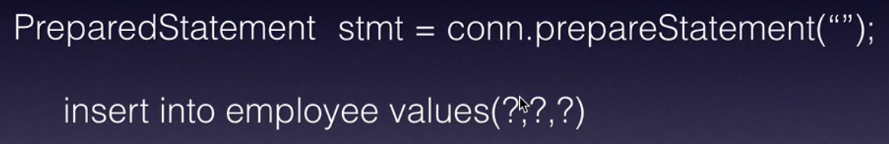

Later to assign values for the placeholders, we use stmt.setXXX( ) methods. This process is called binding the values to the placeholders.
Compilation of the sql statement happens right at the call conn.prepareStatement(" "); This will improve the performance.

public void init(){
try {
Class.forName("com.mysql.jdbc.Driver");
conn = DriverManager.getConnection(
"jdbc:mysql://localhost/mylocaldb", "root", "chotu123");
// this is a prepared statement, compiled only once
stmt = conn.prepareStatement("insert into product values(?, ?, ?, ?)");
} catch (ClassNotFoundException e) {
e.printStackTrace();
} catch (SQLException e) {
e.printStackTrace();
}
}

protected void doPost(HttpServletRequest request,
HttpServletResponse response) throws ServletException, IOException {

int id = Integer.parseInt(request.getParameter("id"));
String name = request.getParameter("name");
String desc = request.getParameter("description");
int price = Integer.parseInt(request.getParameter("price"));

try {
stmt.setInt(1, id);
stmt.setString(2, name);
stmt.setString(3, desc);
stmt.setInt(4, price);

int result = stmt.executeUpdate();
if(result > 0){
PrintWriter out = response.getWriter();
response.setContentType("text/html");
out.print("<b>Product created..</b>");
}

} catch (SQLException e) {
e.printStackTrace();
}
}

